

**Hotel Management System**

**(ERD & CD)**

**Submitted To:**

**Mam Sadaf Naeem**

**Project Team:**

|  |  |  |  |  |  |
| --- | --- | --- | --- | --- | --- |
| List | Roll # | | Names | | Contributions |
| 1 | | 231400033 | | Ehtasham Maqbool | 33% |
| 2 | | 231400038 | | M. Bilal | 33% |
| 3 | | 231400126 | | Afaq Hussain | 33% |

**Project Number:**

**Group 9**

**Section: D**

**Table of Contents**

**1.** **Class Diagram** 3

**2.** **ERD** 4

**3.** **References** 5

# **Class Diagram**

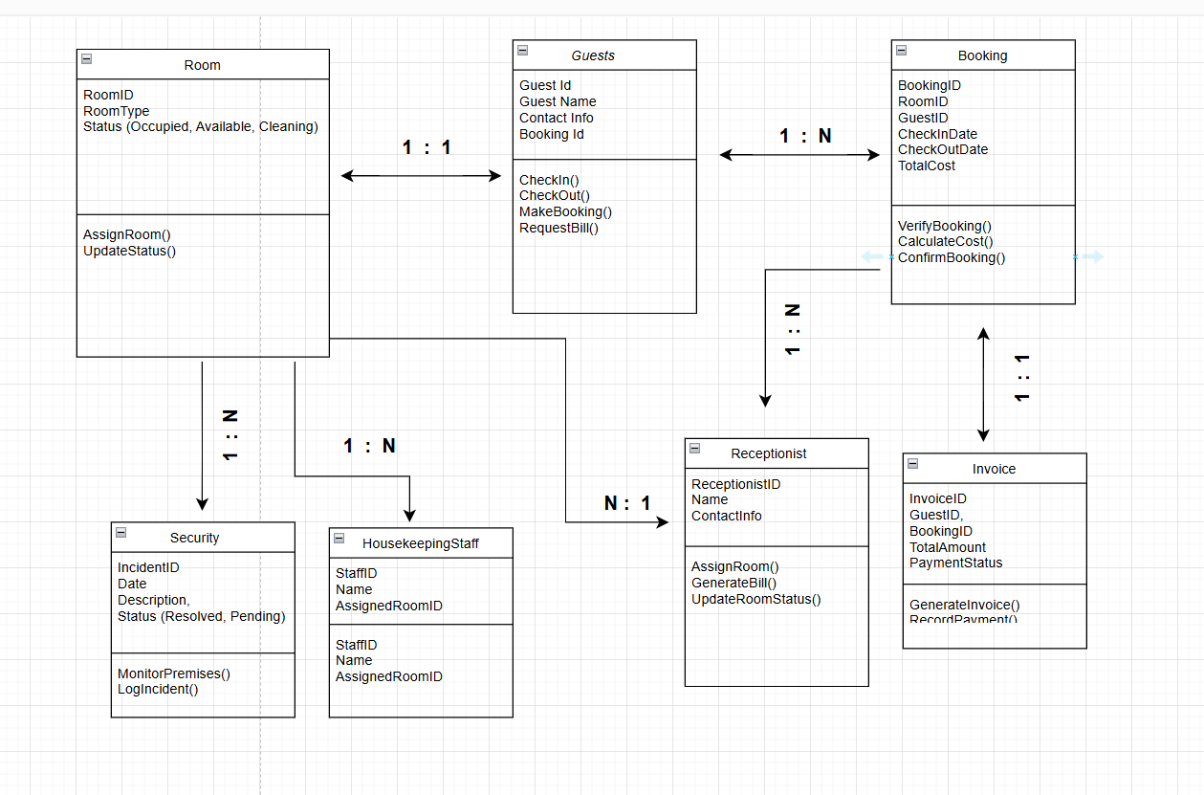

# **ERD**

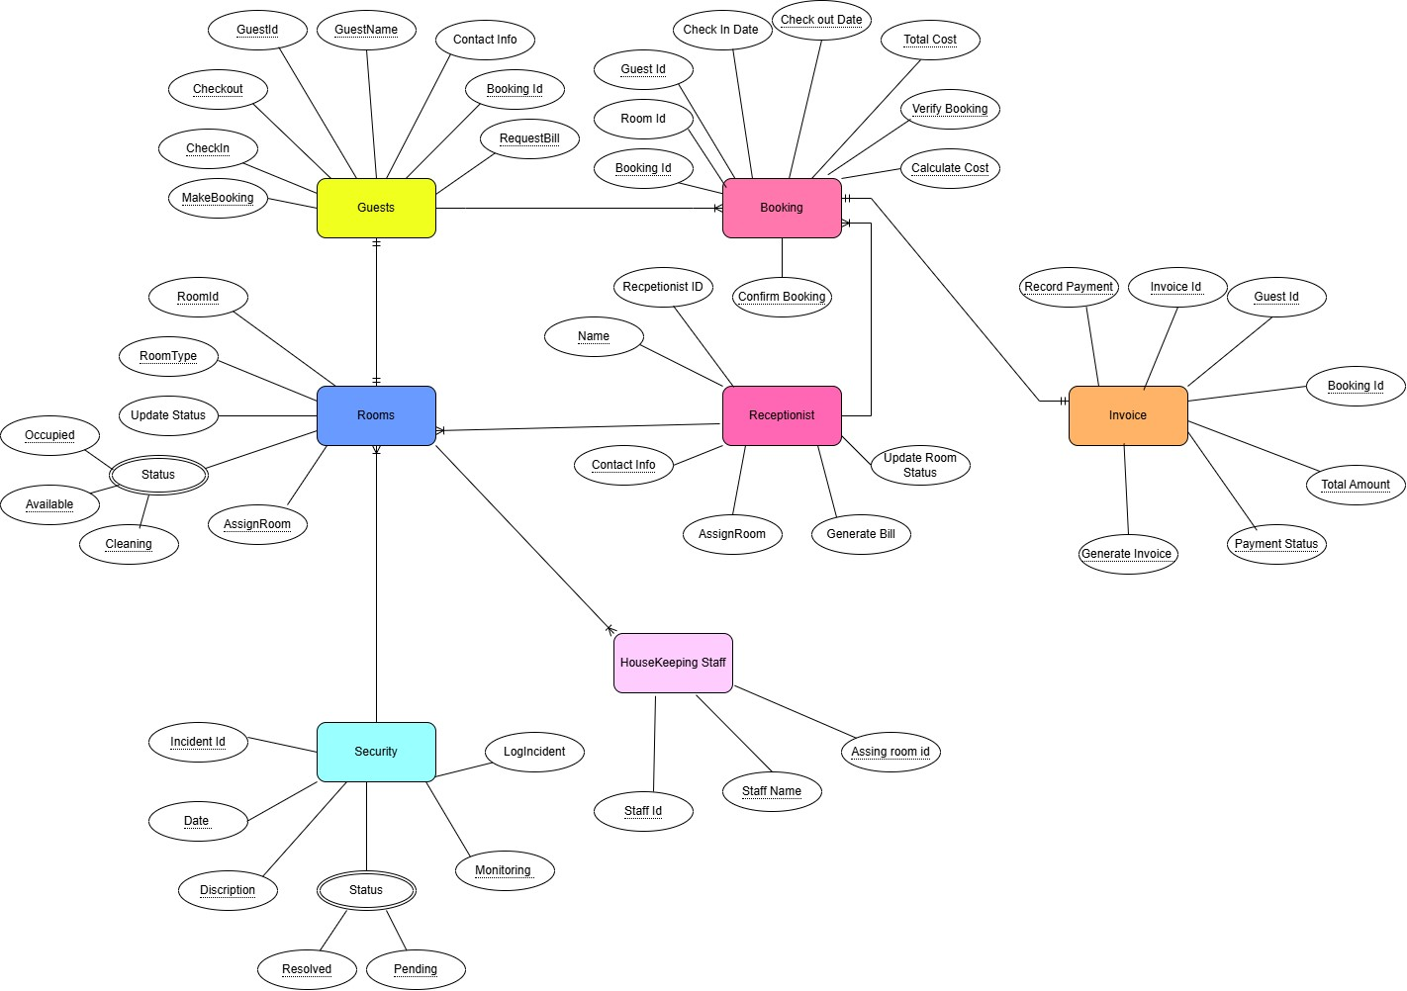

# **References**

* + - 1. Taj Hotels India Mumbai
         1. <https://www.tajhotels.com/en-in/epicureprogram?utm_source=google&utm_medium=cpc&utm_campaign=Pmax_epicure&gad_source=1>
      2. Pearl-Continental Hotel Lahore

b. <https://www.pchotels.com/hotel-and-resort/pearl-continental-hotel-lahore>

1. Social Science Research Network (SSRN)
   * + 1. <https://papers.ssrn.com/sol3/papers.cfm?abstract_id=4352593>
       2. https://papers.ssrn.com/sol3/papers.cfm?abstract_id=4920386